# Test Document for IR (Received Purchase Invoices – tfacp1500m000)” required to be attached

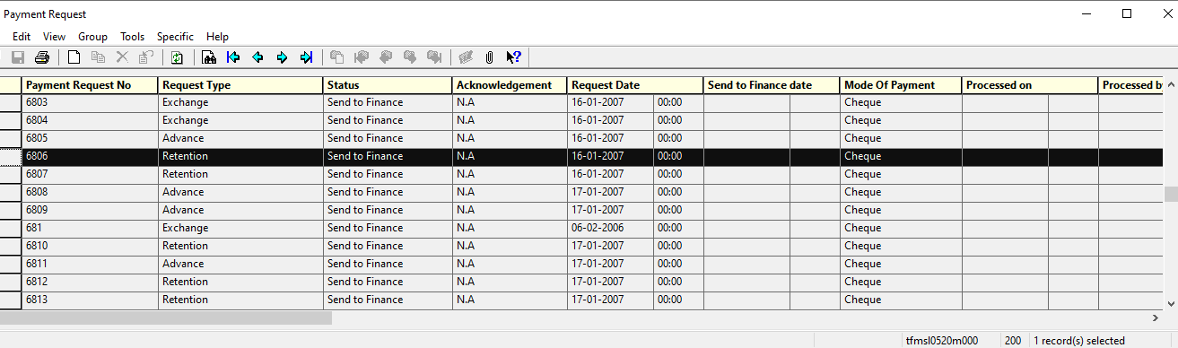

In Specific -> IR (Received Purchase Invoices – tfacp1500m000) added

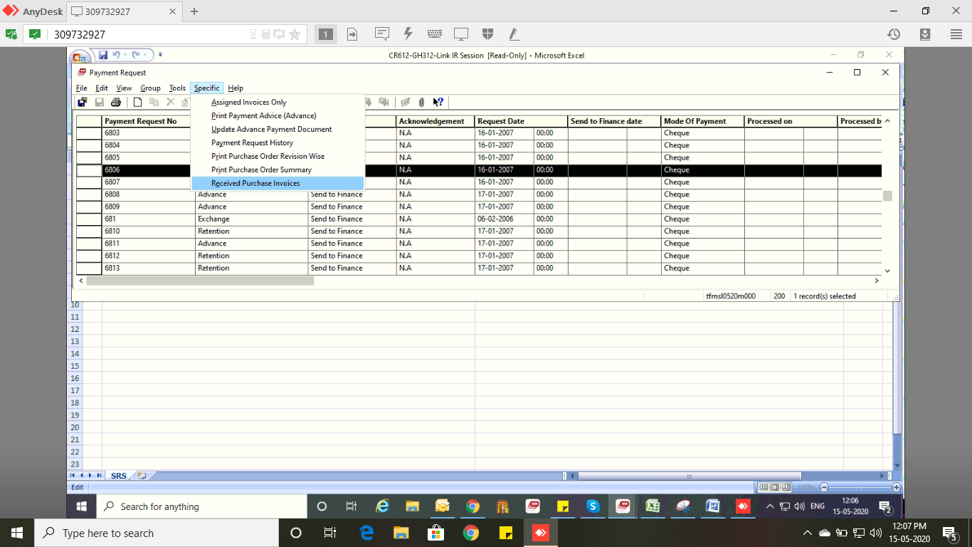

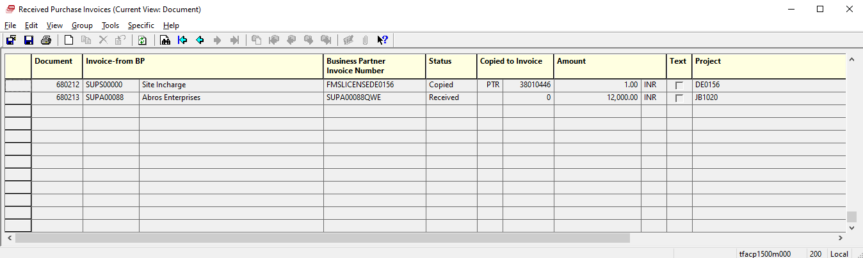

Similarly, In Session tfmsl0120m000 and tfisg1201m000 add session in tfacp1500m000 in specific.

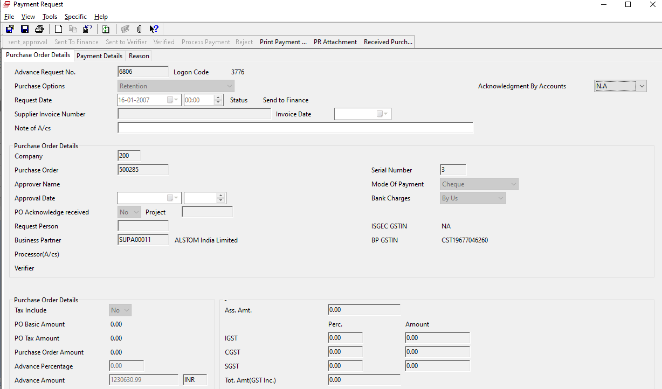



In session Purchase Order Invoice Booking session – tfisg1201m000

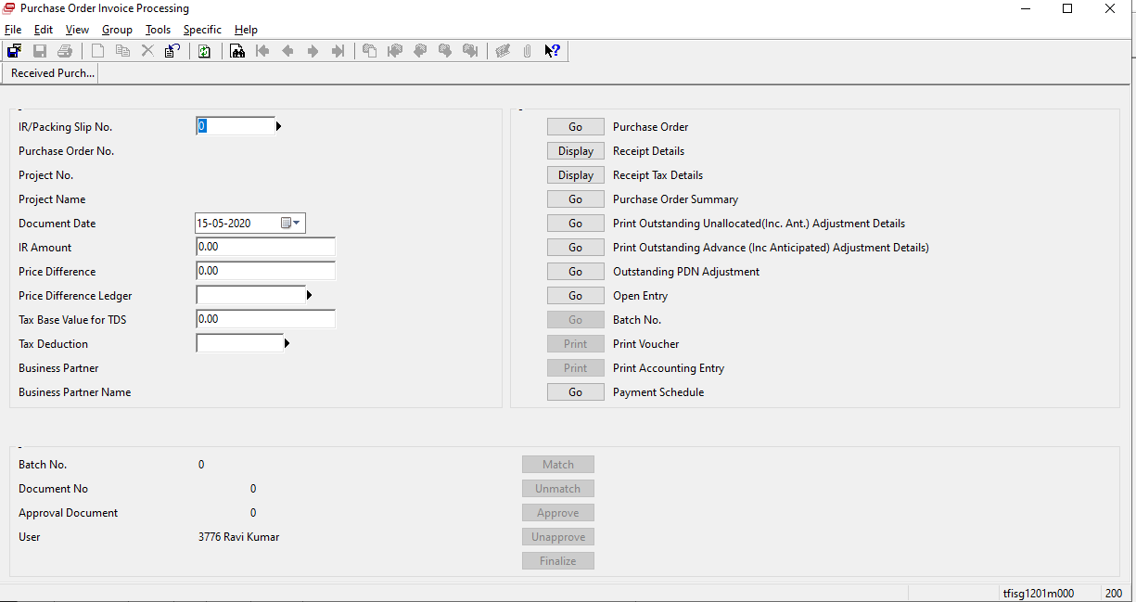

In specific also added



